SIMATS ENGINEERING
CO3-ASSESSMENT TOOL 1
Experiments
COURSE NAME: Computer Networks COURSE CODE: CSA0713
COURSE OUTCOME COVERED
CO3: Analyze the performance of core network protocols such as TCP, UDP, HTTP, and DNS under varying conditions
Assessment Tool Weightage: 40%
Dr.V.Parthipan
Code of Conduct:
I Suganthan K-( 192424105) (Name / Reg No) certify that this submission is my original work and that I have adhered to the guidelines specified for this assessment. I understand that any violation of academic integrity rules will result in disciplinary action.
Signature of the student-
K Suganthan
Criteria | Understandi ng of  Concepts  2.5 | Experimental  Design  3 | Use of  Tools  2 | Analysis of Results  1.5 | Documenta  tion  1 | Total (10)
Q1 | 2.25 | 2.7 | 1.8 | 1.35 | 0.9 | 9
Q2 | 2.25 | 2.7 | 1.8 | 1.35 | 0.9 | 9
Q3 | 2.25 | 2.7 | 1.8 | 1.35 | 0.9 | 9
Q4 | 2.25 | 2.7 | 1.8 | 1.35 | 0.9 | 9
Faculty Signature

Experiments
QUESTIONS:4 Total Marks:40
- Capture packets during a TCP connection setup. Identify the three packets involved in the handshake (SYN, SYN-ACK, and ACK). Demonstrate the role of each flag and how they establish a reliable connection. (BL4) (10)

- Capture a DNS query using UDP in Wireshark. Compare the UDP header size with TCP and note the absence of sequence numbers or acknowledgments. Discuss how this lightweight design impacts speed and reliability. (BL4) (10)

- Simulate packet loss (e.g., disconnect briefly) and capture traffic in Wireshark. Observe how TCP retransmits lost packets while UDP does not. Explain why this difference makes TCP reliable but slower compared to UDP. (BL4 (10)

- Use Wireshark to capture DNS traffic while resolving a domain name. Identify the query type (A, AAAA, MX) and the response received. Measure the time taken for resolution and explain why DNS typically uses UDP.(BL4) (10)

=

Experiment 1: TCP Three-Way Handshake (10 Marks)
Aim: To capture and analyze the TCP three-way handshake using Wireshark.
Procedure:
- Open Wireshark and start packet capture.
- Open any website.
- Stop the capture.
- Apply the filter tcp.
- Identify the SYN, SYN-ACK, and ACK packets.
Observation:
- SYN: Client requests a connection.
- SYN-ACK: Server accepts the request and acknowledges it.
- ACK: Client acknowledges the server, and the connection is established.
Out Put:
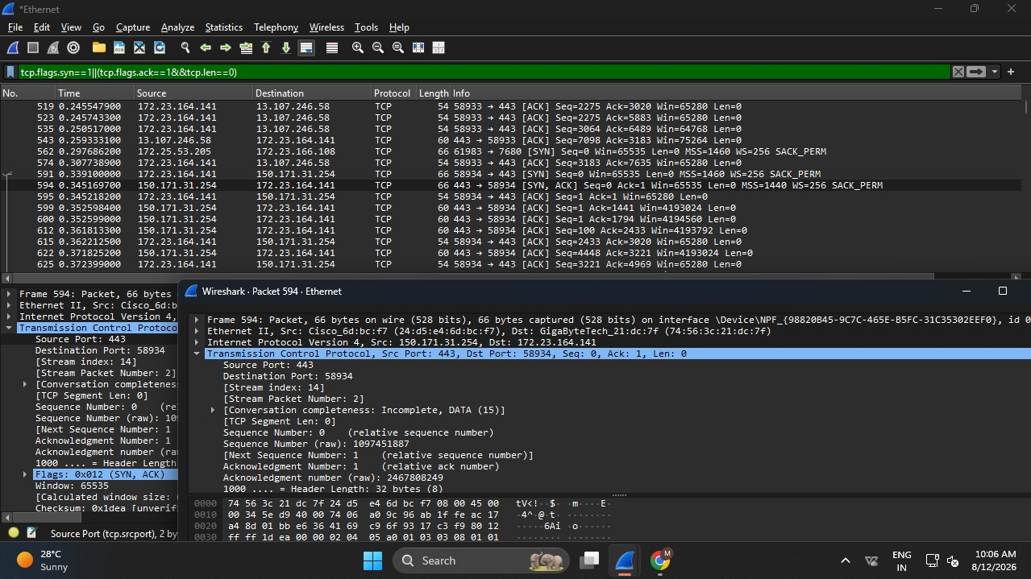

Result:
TCP uses a three-way handshake to establish a reliable connection before data transfer.

Experiment 2: DNS Query Using UDP (10 Marks)
Aim: To capture a DNS query and compare UDP with TCP.
Procedure:
- Start Wireshark capture.
- Open a website.
- Stop the capture.
- Apply the filter dns. Observation:
UDP TCP
Header Size: 8 bytes Header Size: 20 bytes
No sequence numbers Has sequence numbers
No acknowledgments Uses acknowledgments
Faster More reliable
Out Put:
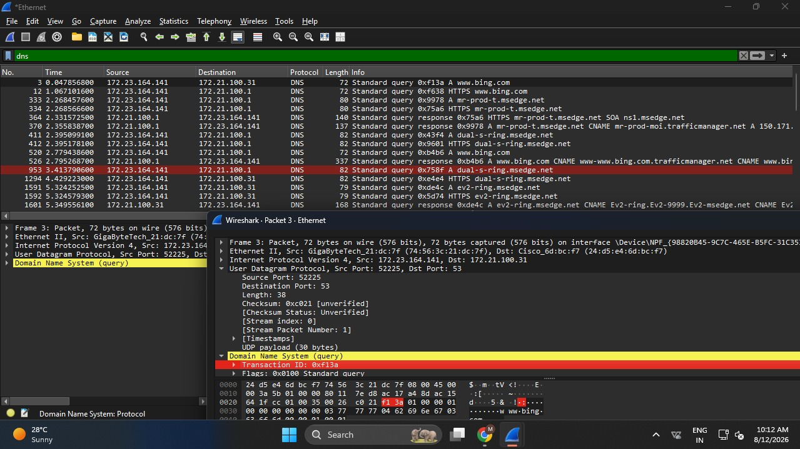
Result:
UDP is faster because it has less overhead, but it is less reliable than TCP.

Experiment 3: TCP Retransmission vs UDP (10 Marks)
Aim: To observe packet loss and compare TCP and UDP behavior.
Procedure:
- Start Wireshark.
- Disconnect the network briefly during data transfer.
- Reconnect and stop the capture.
- Apply the filter tcp.analysis.retransmission.
Observation:
- TCP retransmits lost packets.
- UDP does not retransmit lost packets.
Out Put:
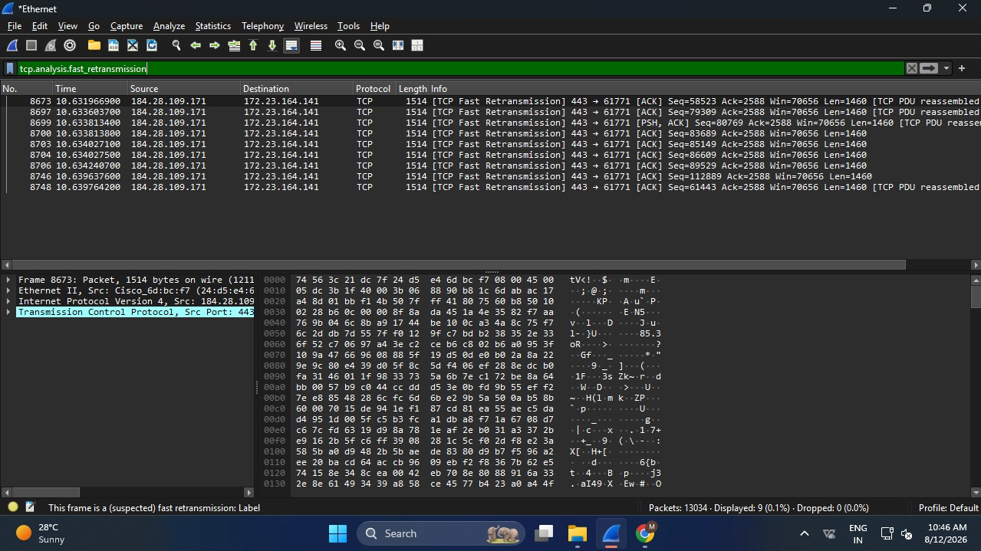
Result:
TCP is reliable because it retransmits lost packets, while UDP is faster but does not recover lost data.

Experiment 4: DNS Traffic Analysis (10 Marks)
Aim: To capture DNS traffic and identify the query type and response.
Procedure:
- Start Wireshark.
- Open a website.
- Stop the capture.
- Apply the filter dns.
Observation:
- Query Type: A (IPv4 address)
- Response: IP address of the website
- DNS Resolution Time: Few milliseconds (depends on the network) Why DNS Uses UDP:
- Faster communication
- Low overhead
- No connection setup required
Out Put:
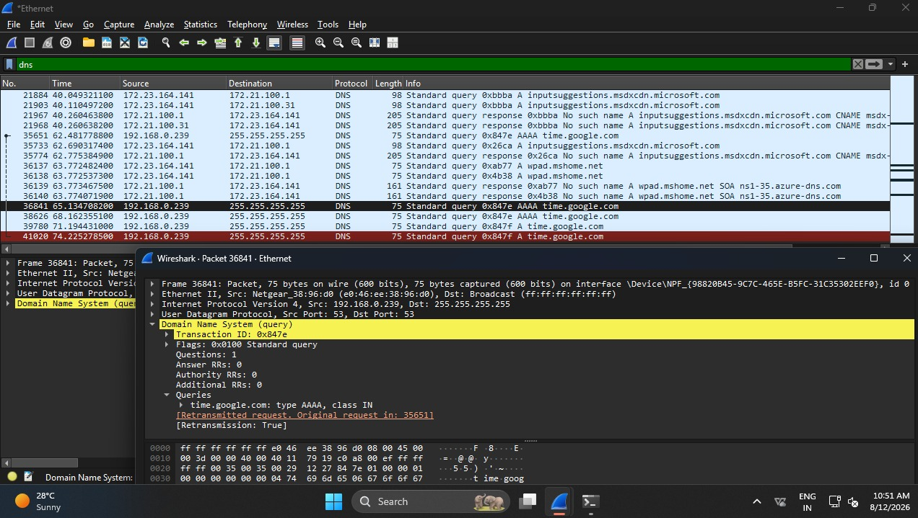
Result:
DNS uses UDP for quick domain name resolution with minimal delay.

RUBRICS FOR CALCULATION:
Criteria | Weightag  e | Level 4 –  Exemplary | Level 3 –  Proficient | Level 2 – Developing | Level 1 – Beginning
Understandin  g of  Concepts | 25 | Demonstrates thorough  understanding and effectively  integrates multiple  concepts/technologi  es | Good understandin g with proper  integration of most concepts | Basic understandin g; limited or partial integration | Poor understandin g; unable to integrate concepts
Experimental Design | 30 | Well-planned, systematic  implementation with optimal solution | Correct implementati  on with minor issues | Basic implementati  on with errors or inefficiencies | Incorrect or incomplete  implementati on
Use of Tools | 20 | Effective and advanced use of  tools/technologies with proper configuration | Appropriate use of tools  with correct execution | Limited or inconsistent use of tools | Incorrect or minimal use of tools
Analysis of Results | 15 | Insightful analysis with accurate  interpretation and validation of results | Good analysis with reasonable interpretation | Basic analysis with limited insights | Poor or incorrect  analysis of results
Documentati on | 10 | Clear, wellstructured documentation with | Organized documentatio n with | Basic documentatio n with | Poor or incomplete documentatio
 |  | diagrams, code, and results | necessary details | missing  details | n

